Getting Started with Simulink: Continuous and Discrete Models

Prerequisites
Prior to starting this guide make sure to install MATLAB and Simulink. For more information, see the files “MATLAB_installation_instructions.pdf” or “COES_Virtual_Desktop_Instructions.pdf”. If installing MATLAB on your personal laptop, it’s recommended that you install all products, but you definitely must select Simulink (and Stateflow for future labs).

Part 1: Modeling a Helicopter Rotor:
The simplified helicopter model given in class lecture has the Yaw dynamics: $T_{y}\left(t\right)=I_{yy}{\ddot{θ}}_{y}\left(t\right)$.
To account for initial angular velocity, the equation can be written as: ${\dot{θ}}_{y}\left(t\right)={\dot{θ}}_{y}\left(0\right)+\frac{1}{I_{yy}}\int_{0}^{t}{T_{y}\left(τ\right)dτ}$.
The simplified helicopter model is a system that takes as input a continuous-time signal $T_{y}$, the Torque around the y-axis which causes changes in yaw. This torque is the sum of the torque caused by the main rotor and that caused by the tail rotor; when perfectly balanced, that sum is zero. The output of our system will be the angular velocity ${\dot{θ}}_{y}$ around the y-axis. This equation can also be represented by the two equivalent actor models shown below:
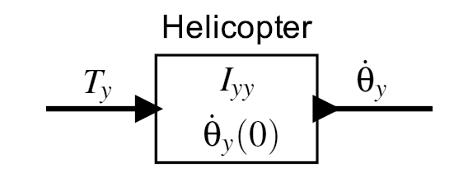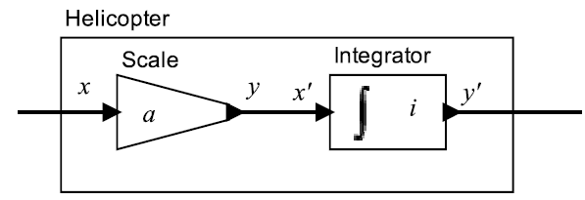
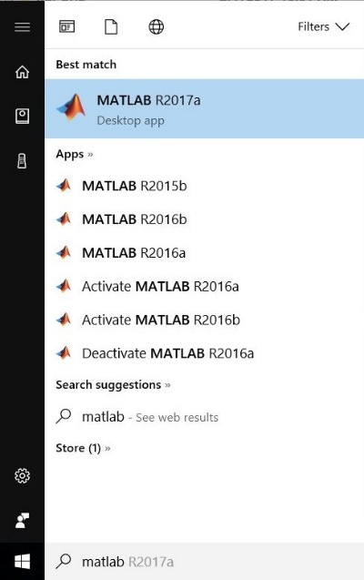
The parameters of this actor are the initial angular velocity, ${\dot{θ}}_{y}\left(0\right)$, and the moment of inertia, $I_{yy}$. Since actor models are composable, we can represent the actor model (at left) by two actors in a cascade composition (at right). The Scale actor is parameterized by the constant a and defined by: $y\left(t\right)=ax(t)$.
The Integrator actor is parameterized by the initial value i and defined by: $y^{'}\left(t\right)=i+\int_{0}^{t}{x^{'}\left(τ\right)dτ}$.
For Part 1, build a Simulink model that emulates the helicopter system. Test the model with the following parameters and initial conditions:
- Moment of Inertia: $I_{yy}=1.0$
- Initial Angular Velocity: ${\dot{θ}}_{y}\left(0\right)=0$
Show that the output is not BIBO stable, given the unit step function as input. If you are already fairly familiar with Simulink, you may proceed with the exercise on your own; otherwise, you may follow the detailed instructions below.
- Click the Windows icon in the bottom-left corner of your screen and type “MATLAB” to find your installation. Select your latest version of MATLAB (e.g. R2019b).
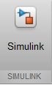
- In the toolbar of the MATLAB program window, select the “Simulink” icon shown at right to open the Simulink Start Page. Under “Simulink”, select “Blank Model” to make a new model called “untitled”. Select the “Save” icon () to save the model as “lab1a.slx”.
- In the toolbar of the “lab1a” window, select the Library browser icon () to open the Simulink library browser. In the left pane, under Simulink, select “Continuous”.
- Continuous systems are most easily modeled starting with the “Integrator” block (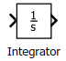). To construct this helicopter system, drag an Integrator block from the Simulink Library Browser into the “lab1a” window. Alternately, you can right-click the Integrator block and select “Add block to model…”
  - To prep for a class discussion, why do you think we use Integrator blocks to model continuous equations and not “Derivative” blocks?
- Another best practice is to immediately draw and label the signals going into and coming out of the Integrator block. The input to the Integrator block is ${\ddot{θ}}_{y}$ (angular acceleration). The output from the Integrator block is ${\dot{θ}}_{y}$ (angular velocity). Drag an arrow from the input port and release, drag an arrow from the output port and release, and then double-click on each arrow to label each signal:
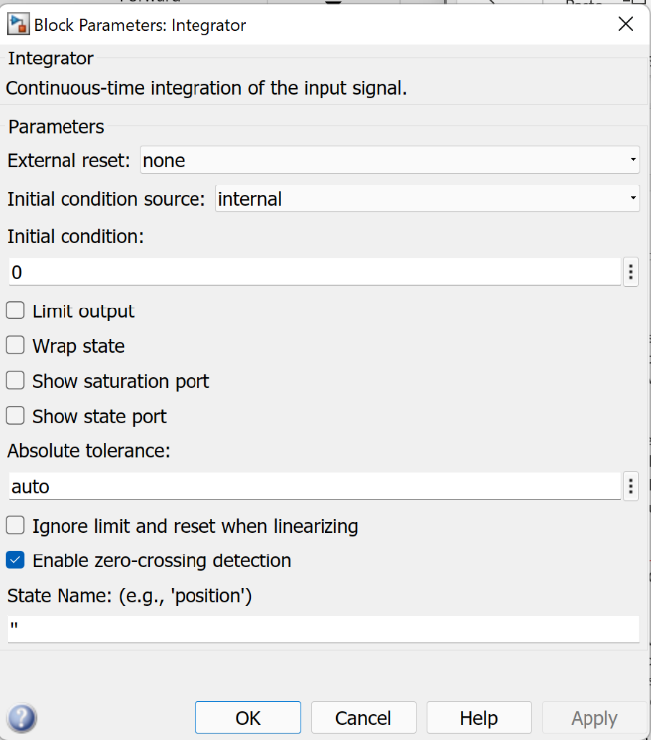
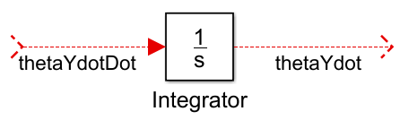
- The initial velocity should be set in each Integrator block. Double-click the Integrator block to open its Block Parameters window, as shown at right. Ensure that the “Initial condition” parameter is set to 0.

- Return to the Simulink Library Browser. In the left pane, under “Simulink”, select “Math Operations”. The Scale actor described above can be modeled by a “Gain” block
(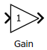). Drag the Gain block from the Library browser into the “lab1a” model window, to the left of the Integrator.

- After inserting the Gain block, you should see a blue box pop up to prompt you to enter a value for the “Gain” parameter. Enter the expression “1/Iyy”, where “Iyy” is a tunable variable that we will set in the MATLAB command window later. If the blue box does not appear, then double-click on the Gain block and enter this expression for the “Gain” parameter. Drag the Gain block (or select it and press your keyboard arrow keys) so that its output port connects to the existing signal ${\ddot{θ}}_{y}$ connected to the input port of the Integrator.
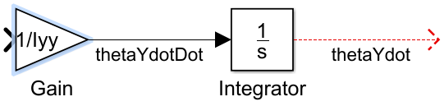
- Return to the Simulink Library Browser. In the left pane, under “Simulink”, select “Sinks”. Drag the “Out1” block from the Library browser into the “lab1a” model window, to the right of the Integrator. Ignore the blue box that appears. Drag the Out1 block (or select it and press your keyboard arrow keys) so that its output port connects to the existing signal ${\dot{θ}}_{y}$ connected to the output port of the Integrator.
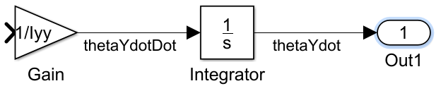
- Return to the Simulink Library Browser. In the left pane, under “Simulink”, select “Sources”. Drag the “Step” block from the Library browser into the “lab1a” model window, to the left of the Gain. To connect the Step and Gain blocks, first select the Step block, then hold down the “Ctrl” Key, and select the Gain block. Alternately, you can drag an arrow from the output of Step to the input of Gain. Double-click the arrow to label the Signal as $T_{y}$, or something similar.
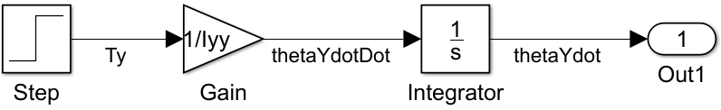
- To see the system output, you can attach a signal viewer to the ${\dot{θ}}_{y}$ signal. To do so, right-click on the signal arrow, and from the context menu select “Create & Connect Viewer” “Simulink” “Scope”. A “Viewer: Scope” window appears. A light blue scope box appears above the signal at the left.

- In the MATLAB command window, enter the command “Iyy=1”. In the Workspace browser, you should see that a new variable has been created named “Iyy” that has a value of 1.

- Run the simulation until a stop time of 5 seconds. In the toolbar of your “lab1a” window, enter a value of “5.0” in the edit box above the word “Normal”. Then, select the Play button ().

- In the Scope window that appears, you should see a yellow line showing the values of ${\dot{θ}}_{y}$ over time. To add $T_{y}$ to this figure also, right-click on the arrow coming out of Step, and from the context menu select “Connect to Viewer” “Scope”. You can also add a legend to the Scope window by selecting the “Configuration Properties” button (), selecting the “Display” tab, and selecting the “Show Legend” checkbox. When the legend is added, the plot should appear as shown:
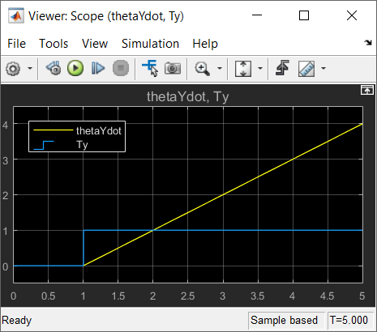
The range of these values illustrates that the helicopter system is not BIBO stable.

- In the MATLAB workspace, note that new variable “out” has been created to capture the simulation output because of the “Out1” block. View it by typing “out.plot”. If you double click this variable, you can see that is made of “tout” (time intervals) and “yout” (output value of function). You can save this variable to a MAT-file by entering the following command at the MATLAB command prompt:
>> save lab1a out

Take screenshots of the Simulink model/schematic, the Simulink graph, AND the MATLAB graph. Complete these steps to get credit for part 1.

Part 2: Modeling a Proportional Controller
For Part 2, build a Simulink model that emulates the Proportional controller system as described in the lecture 3 slides 47-48 and in Lee-Seshia Figure 2.4. Test the model with the following additional parameters and constants:
- Constant Torque due to the top rotor: $T_{t}\left(t\right)=0.5u\left(t\right)$
- Constant Desired Angular Velocity: $ψ(t)=0.0$
- Controller Proportional Gain: $K_{p}=10$
Show a graph of the output angular velocity, ${\dot{θ}}_{y}$, and the angle, $θ_{y}$. If you are already fairly familiar with Simulink, you may proceed with the exercise on your own; otherwise, you may follow the detailed instructions below.

- In the lab1a model window, select “FileSave As…”. Change the file name to “lab1b.slx” and select “Save”.
- Right-click on the light blue Scope icon to the right of Integrator, and select “Delete ViewerScope”. Select the Step block and press the “Del” key. Alternately, right-click on it and select “Delete”.
- Return to the Simulink Library Browser. In the left pane, under “Simulink”, select “Commonly Used Blocks”. Drag the “Sum” block () from the Library browser into the “lab1b” model window, to the left of the Gain block. Drag the Sum block (or select it and press your keyboard arrow keys) so that its 1st of 2 output ports connects to the existing signal $T_{y}$ going into the Gain block.
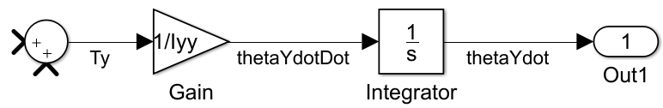
- Drag a box around all the blocks and arrows in the model to select them all (or type Ctrl-A). From the lab1b menu that will be at the very top, select “Multiple Create Subsystem” button (or type Ctrl-G).
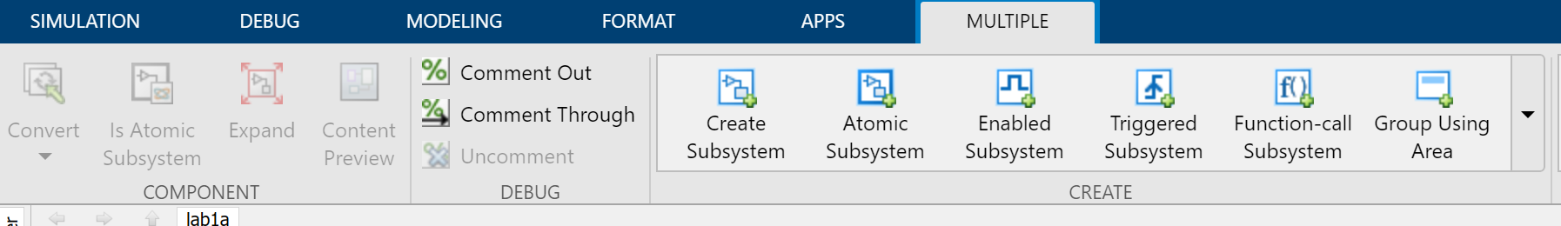

- This encapsulates all the existing blocks into a single block called Subsystem. Rename Subsystem by clicking its name below the block and typing “Helicopter Plant”.

- Double-click the “Helicopter Plant” block to enter the subsystem. You can change the input and output port names on the block by renaming the “In#” and “Out#” blocks within the subsystem. Rename “In1” to “Tt”, rename “In2” to “Tr”, and rename “Out1” to “ThetaDot”. Then, select the “Up” icon () or the lab1b icon () to return to the top-level parent model.
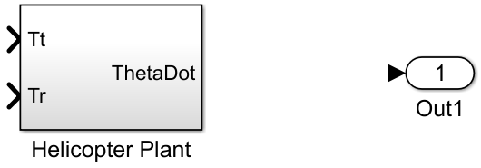
- Drag another Integrator block from the Simulink Library Browser into the bottom-right of the “lab1b” window. If the blue box appears, set the initial condition to value 0. Right-click on the “Out1” block and drag it straight down to create a copy named “Out2”. Double-click the signal coming out of the Helicopter Plant block and label it “ThetaDot”. Connect the signal ThetaDot to the Integrator block by right-clicking the signal and dragging the mouse to the Integrator input port. Connect the output of the Integrator port to the “Out2” block, and label the resulting signal “Theta”. Rename “Out1” as “ThetaDot” and “Out2” as “Theta”.
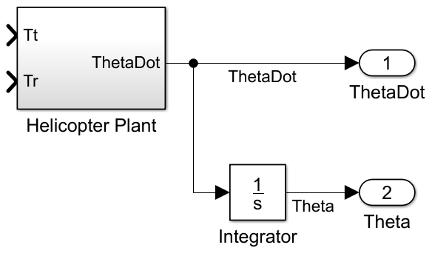
- Return to the Simulink Library Browser. In the left pane, under “Commonly Used Blocks”, select “Constant”. Drag the “Constant” block from the Library browser into the “lab1b” model window, to the left of the Helicopter Plant input port Tt. When the blue box appears, set “Constant Value” to “0.5”. Rename the block as “Tt”. Right-click the block and drag it straight down to make a copy called “Tt2”. Rename the block as “Psi”. Double-click the block to change “Constant Value” to 0. Connect the constant block “Tt” to the 1st input port “Tt” on the Helicopter Plant block.
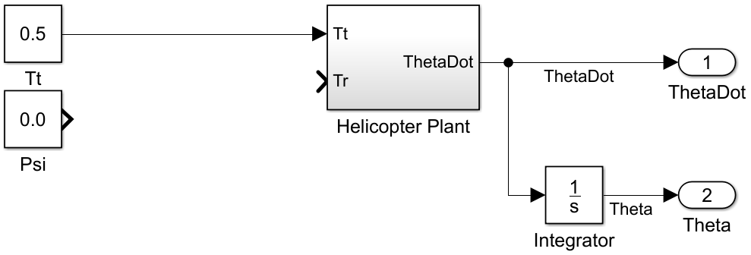
- Return to the Simulink Library Browser. In the left pane, under “Commonly Used Blocks”, select “Sum”. Drag the “Sum” block from the Library browser into the “lab1b” model window, to the right of the constant block “Psi”. When the blue box appears, set “List of Signs” to “|+-”. Connect the constant block “Psi” to the “+” input port, and connect the “–“ input port to the existing signal “ThetaDot”.
- Return to the Simulink Library Browser. In the left pane, under “Commonly Used Blocks”, select “Gain”. Drag the “Gain” block from the Library browser into the “lab1b” model window, to the right of the subtract block. When the blue box appears, set “Gain” to “Kp”. Connect the output of the subtract block to the input of Gain, and label the resulting signal as “e”, for error signal. Connect the output of the Gain block to the 2nd input port “Tr” on the Helicopter Plant block.
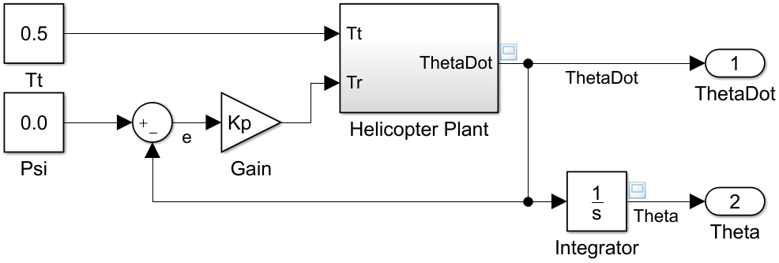

- To see the system output, you can attach a signal viewer to the “ThetaDot” signal. To do so, right-click on the signal arrow, and from the context menu select “Create & Connect Viewer” “Simulink” “Scope”. A “Viewer: Scope” window appears. A light blue scope box appears above the signal.

- In the MATLAB command window, enter the command “Kp=10”. In the Workspace browser, you should see that a new variable has been created named “Kp” that has a value of 10.

- Run the simulation until a stop time of 5 seconds. In the toolbar of your “lab1b” window, ensure that a value of “5.0” is in the edit box to the left of the word “Normal”. Then, select the Play button ().
- In the Scope window that appears, you should see a yellow line showing the values of ThetaDot over time. To add Theta to this figure also, right-click on the signal Theta, and from the context menu select “Connect to Viewer” “Scope”. You can also add a legend to the Scope window by selecting the “Configuration Properties” button (), selecting the “Display” tab, and selecting the “Show Legend” checkbox. When the legend is added, the plot should appear as shown:
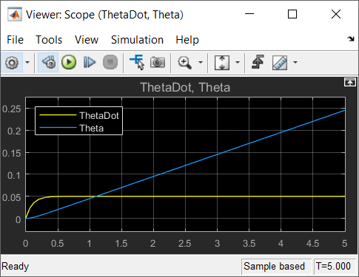
- Discuss with your neighbor how the value of K_{p} affects the system behavior. At the MATLAB command prompt, change the value of K_{p} to 100. Rerun the Simulation and observe the Scope. How does this parameter value affect the output values of ThetaDot and Theta?

- In the MATLAB workspace, note that new variable “out” havs been updated to capture the simulation output from the Out1 and Out2 blocks. View by typing “out.plot”. You can save this variable to a MAT-file by entering the following command at the MATLAB command prompt:
>> save lab1b out

Take screenshots of the Simulink model/schematic, the Simulink scope, AND the MATLAB plot. Complete these steps to get credit for part 2.

Part 3: Modeling a Discrete Proportional-Integral (PI) Controller
For Part 3, build a Simulink model that emulates a Discrete Proportional-Integral controller system. For this system, the output of the discrete PI controller is the sum of two individual controller outputs — proportional and integral controls:
$$T_{r}\left(k\right)=T_{p}\left(k\right)+T_{i}\left(k\right)$$
Where:
$$T_{p}\left(k\right)=K_{p}e\left(k\right) \\ T_{i}\left(k\right)=T_{i}\left(k-1\right)+K_{i}t_{s}e\left(k\right)$$Note that unlike the previous continuous systems that were modeled using differential equations, this PI controller is a discrete system and so it is modeled by difference equations. Test the model with the following parameters and constants:
- Constant Torque due to the top rotor: $T_{t}\left(t\right)=0.5u\left(t\right)$
- Constant Desired Angular Velocity: $ψ(t)=0$
- Controller Proportional Gain: $K_{p}=10$
- Controller Integral Gain: $K_{i}=10$
- Sample Time: $t_{s}=0.1 sec$
- Initial Torque Conditions: $T_{i}(0)=0$
Show a graph of the output angular velocity, ${\dot{θ}}_{y}$, and the angle, $θ_{y}$.
- In the lab1b model window, select “FileSave As…”. Change the file name to “lab1c.slx” and select “Save”. Select the Gain block with parameter “Kp”, rename it as “Proportional Gain”, and type Ctrl-G to turn it into a Subsystem. Rename the Subsystem as “Controller” and rename its input port as “e_k” and its output port as “Tr_k”.

- Instead of Integrators, you should use a “Unit Delay” block from the “Discrete” library to make the transformation from x(k) at the input port to x(k–1) at the output port. Double-click the Unit Delay block to set the delay length to 1, the initial condition to 0.0, and the sample time to ts.

- Remember to set all the new parameters to which your Simulink model refers in the MATLAB workspace: ts=0.1; Ki=10; Then, press the Play button to Simulate again. If you’ve modeled this new system correctly, then the Scope output should appear to be something like the following:
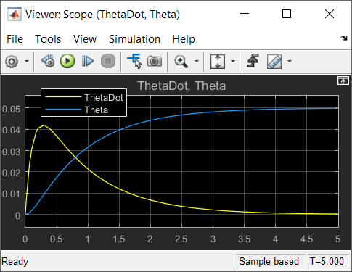
In your opinion, does the inclusion of the Integral component of the controller make a significant impact on keeping the angle of rotation steady? How so?

- In the MATLAB workspace, note that new variable “out” has been updated to capture the simulation output from the Out1 and Out2 blocks. View by typing “out.plot”. You can save the variable to a MAT-file by entering the following command at the MATLAB command prompt:
>> save lab1c out

Take screenshots of the Simulink model/schematic, the Simulink scope, AND the MATLAB plot. Complete these steps to get credit for part 3.

Part 4: Modeling a Discrete Proportional-Integral-Derivative (PID) Controller
For Part 4, build a Simulink model that emulates a Discrete Proportional-Integral-Derivative controller system. For this system, the output of a discrete PID controller is the sum of three individual controller outputs — proportional, integral, and derivative controls:
$$T_{r}\left(k\right)=T_{p}\left(k\right)+T_{i}\left(k\right)+T_{d}\left(k\right)$$
Where:
$$T_{p}\left(k\right)=K_{p}e\left(k\right) \\ T_{i}\left(k\right)=T_{i}\left(k-1\right)+K_{i}t_{s}e\left(k\right) \\ T_{d}\left(k\right)=\frac{K_{d}}{t_{s}}\left[e\left(k\right)-e\left(k-1\right)\right]$$
Test the model with the following parameters and constants:
- Constant Torque due to the top rotor: $T_{t}\left(t\right)=0.5u\left(t\right)$
- Constant Desired Angular Velocity: $ψ(t)=0$
- Controller Proportional Gain: $K_{p}=10$
- Controller Integral Gain: $K_{i}=10$
- Controller Derivative Gain: $K_{d}=2$
- Sample Time: $t_{s}=0.1 sec$
- Initial Torque Conditions: $T_{i}(0)=0$
Show a graph of the output angular velocity, ${\dot{θ}}_{y}$, and the angle, $θ_{y}$.
- Save lab1c as lab1d.slx. Update the Controller Subsystem to reflect the differential equations shown above. You will have to add a new Unit Delay block, which this time is to delay the error signal and produce e(k–1). Remember to set all the new parameters to which your Simulink model refers in the MATLAB workspace: Kd=2; Then, press the Play button to Simulate again. If you’ve modeled this new system correctly, then the Scope output should appear to be something like the following:
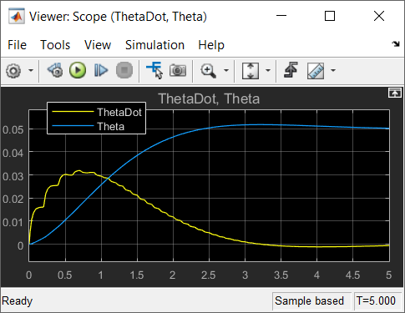
In your opinion, does the inclusion of the Derivative component of the controller make a significant impact on keeping the angle of rotation steady? How so?

- In the MATLAB workspace, note that new variable “out” has been updated to capture the simulation output from the Out1 and Out2 blocks. View by typing “out.plot”. You can save the variable to a MAT-file by entering the following command at the MATLAB command prompt:
>> save lab1d out

Once you’ve completed these steps, you may call over the instructor to mark you down for Part 4.

